|  |  |  |  |  |  |  |  |  |  |  |  |
| --- | --- | --- | --- | --- | --- | --- | --- | --- | --- | --- | --- |
| |  |  |  |  |  | | --- | --- | --- | --- | --- | | **Scenario:**  Monitoring child location |  | **Entice**  How child location is monitored? |  | **Enter**  How message is been notified to user? | | |  | | --- | | **Engage**  In the core moments in the process, what happens? | | |  | | --- | | **Exit**  What do people typically  experience as the process finishes? | | |  | | --- | | **Extend**  What happens after the experience is over? | |

|  |  |  |  |  |  |  |  |  |  |  |  |  |  |  |  |  |  |  |  |  |  |  |  |  |  |  |  |  |  |  |  |  |  |  |  |  |  |  |  |  |  |  |  |  |  |  |  |  |  |  |  |
| --- | --- | --- | --- | --- | --- | --- | --- | --- | --- | --- | --- | --- | --- | --- | --- | --- | --- | --- | --- | --- | --- | --- | --- | --- | --- | --- | --- | --- | --- | --- | --- | --- | --- | --- | --- | --- | --- | --- | --- | --- | --- | --- | --- | --- | --- | --- | --- | --- | --- | --- | --- |
| |  | | --- | | Create a | |  | | web | |  | |  | | application | | |  | | --- | | Parent can | |  | | create | |  | |  | | geofence | |  | | |  | | --- | |  | | Check whether | | child is inside | |  | | geofence | |  | |  | | |  | | --- | | Updating of | |  | | child | |  | |  | | location | | |  | | --- | |  | |  | | Location of child | | sent periodically | |  | |  | | |  | | --- | |  | | Review of | |  | |  | | application | |  | | |  | | --- | |  | | Alert | |  | |  | | parents | |  | |  | |

**Steps**

**Interaction**

|  |
| --- |
| Connection terminated when gps is |

|  |
| --- |
| Setting geofence |

|  |  |  |
| --- | --- | --- |
| Regular updates |  | Parent needs are meet |

|  |  |  |
| --- | --- | --- |
| Interacting with child |  | Guiding child |

of

|  |  |  |  |
| --- | --- | --- | --- |
| |  | | --- | | Regular monitoring | | |  | | --- | | Geofence need to be set | |

|  |  |  |
| --- | --- | --- |
|  |  |  |
| Location |  |
|  | location is |
| is sent |  |
|  |  |

|  |  |  |
| --- | --- | --- |
| Taking care of |  | Notifying when |
|  |  |
| child in | child crosses |
|  |  |
| absence | geofence |
|  |  |

|  |
| --- |
|  |
| Monitori |
|  |
| ng child |
|  |

|  |
| --- |
|  |
| Prevent child |
|  |
| missing |
|  |
|  |

Geofence

**Goals and**

**motivation**set



**Positive**

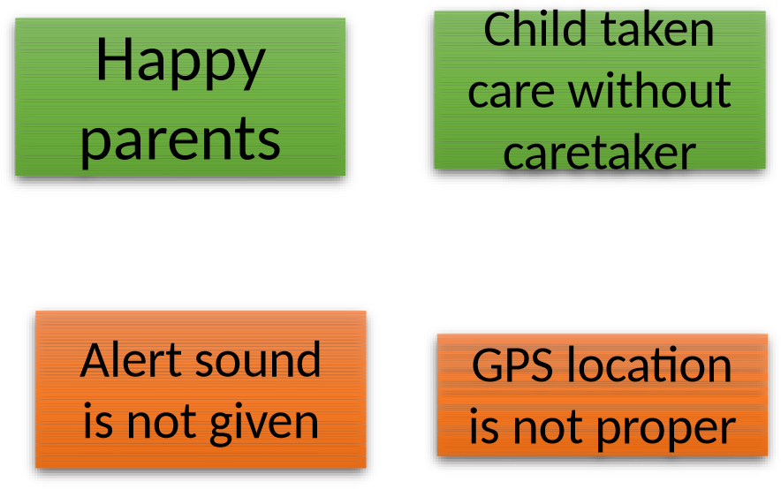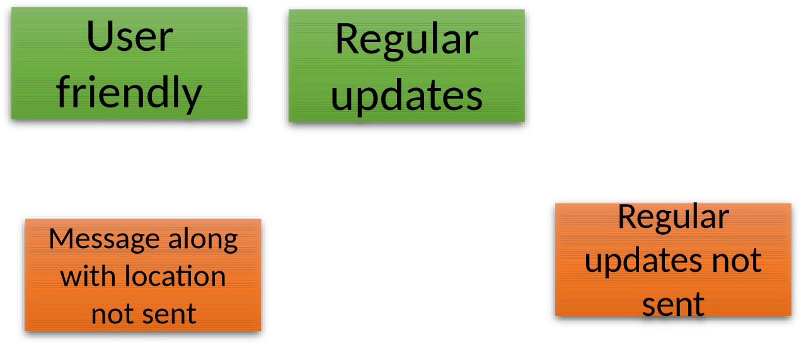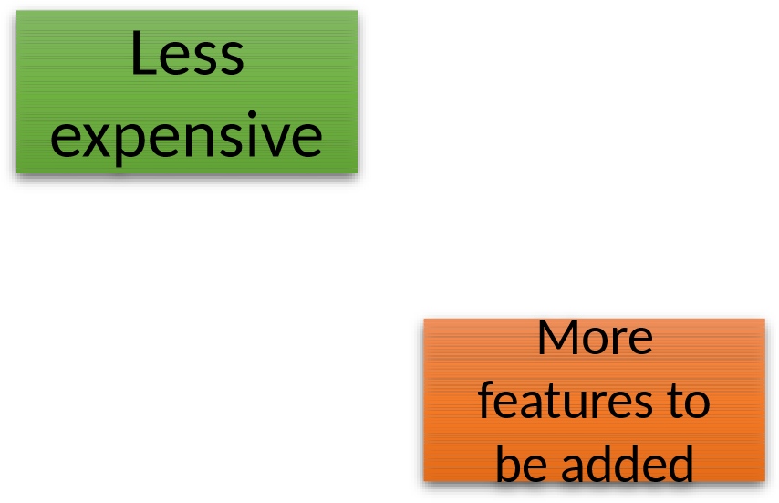

**moments**

**Negative moments**

**Areas of**

|  |
| --- |
| Periodic updates of child location |

|  |  |  |
| --- | --- | --- |
| In absence of caretaker |  | Alert sound along with |

|  |  |  |
| --- | --- | --- |
| Alternate options if message not sent |  | Where no one is able to take care of child |

|  |
| --- |
| Reviews may not asked frequently |

**opportunity** mass